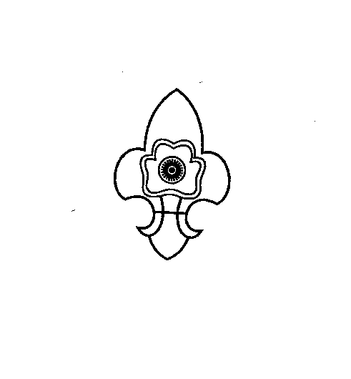
+
THE MEGHALAYA BHARAT SCOUTS & GUIDES

“Empowering the Youth, Powering the Nation”
STATE HEADQUARTERS::: PINEMOUNT-RIDGE
SHILLONG - 1.
Phone No & Fax No: (0364) 2226197
www.megscoutguide.nic.in
Email: mbsg_meghalaya@yahoo.co.in & meghalayascoutsandguides@gmail.com

No: MBSG/A-14/2021/ Date:5th February 2021

To
All the MSGF Members & Commissioners of
the Meghalaya Bharat Scouts and Guides.

Subject: Celebration of Founder’s Day and World Thinking Day 2021.

Dear Members,
Greetings! From the Fraternity of the Meghalaya Bharat Scouts and Guides.
The first activity of the year 2021 will be the Celebration of the “Founder’s Day and World Thinking Day” which is celebrated all over the World on the 22nd of February of each year, being the Joint Birthday of the Founder and his Wife. The theme for this year is “Stand Together for Peace”.
The Founder’s Day and Thinking Day celebration will therefore be celebrated at the Baden Powell Auditorium State Headquarters on the 22nd February 2021 at 11:00 a.m. with the inauguration of the “Free Being Me - Action on Body Confidence Workshop” which will be held for 3 days from the 22nd to 24th February 2021 for the Rovers/Rangers/Scouts/Guides.
In this regard you are cordially invited to attend the Programme to celebrate along with all the members of the Movement. You are also requested to kindly attend the programme in Uniform or with a scarf and contribution for the “World Thinking Day” will be collected on that day.
Thanking you
(Mrs. A. Swer)
State Secretary
MBSG, Shillong

